The Neuro D Translation Guide for Normies

*NDs: “The Single Greatest Misconception About Communication Is The Illusion that It Has Taken Place”*

*NTs: “That’s too much, wtf are you even saying?”*

*NDs: “You Are Constantly Misunderstood and You Don’t Even Know It”*

*NTs: “Why didn’t you just say THAT?!”*

*NDs: “....I did”*

*NTs: “No, you didn’t”*

*NDs: <meltdown>*

Miscommunication creates problems. With the right tools, be they verbal, or nonverbal, we can prevent many misunderstandings, conflicts, and unfortunate situations from taking place.

This is a guide and primer intended to bridge understanding between autistic and allistic. Think of it as an ‘Operating System’ serving as a communication framework. It does not require words, but we exist in word space to explain these ideas. Sometimes in stress, overload, or joy, words are difficult to use. It is common for communication to take place through body language, actions, analogies, and artful expressions. Three concepts we will cover today are the Table, the Checklist, and the Scale.

# The Table

*A concept to describe stress levels*

The Table is a model to describe the way the mind handles the limitation of bandwidth. The table represents what goes on in working memory.

Think of an empty table. We can infer a few things

* The bigger the table, the more you can put on it without having to “clean up,”
* There’s a point where putting things on the table leads to the table “feeling” full,
* There may be space on the table, but organization matters

As things pile up on the table, the amount of available “bandwidth” for more decreases. As things are less organized, the clutter can make it feel like there is less space than there is. If we assume that the table is the only place things can go to stay in line with the metaphor of the mind then as the table gets more full and more cluttered, we have to take more and more time to keep it organized. In fact the science has shown that the less free space we have on the Table, the harder it is for us to choose.

For NDs, everything has to either be removed or left on the table and not matter whether they are removed or not, we need to document the things and where they are and why before changing contexts.

Ever manically clear out clutter because it was just too much? That’s why NDs forget things.

Each item on the table, or being removed from it needs to be evaluated against every other item - is it the right item to remove? Is there a more valuable one?

This is not only exhausting but at some point there’s just too much and things get inefficient.

**Communication using The Table may consist of:**

* The degree of clutter
* How full it is
* Whether or not it needs organizing
* How much free space there seems to be
* The amount of effort it would take to free space

### For a neuro-divergent:

We enjoy filling the table. And for us as the table gets too full it also seems to shrink, so our goal is to clean up the table and re-organize it faster than it shrinks. All of this is going on inside of our heads, so when you are interacting with us and suddenly we go “offline” or when we suddenly seem irritable, it’s because of our “executive functioning,” which slows down our ability to choose what and how to clean up. It also impacts our ability to know what’s relevant to leave on the table vs put away. Burnout happens when there’s too much moving on the table too fast. Once we tend to perceive as there being less “free space” the table begins shrinking, so it has a manic effect.

A healthy table is one where one can ebb and flow with in terms of the amount of things “on it.” It’s never quite full, but never empty. In a healthy state, the symptom of bouncing from thing to thing to clean the clutter is reduced because the desperation of trying to maintain the table is minimized - the table hasn’t hit its critical mass and started shrinking.

## The Checklist

*A tool for tracking things on the Table*

The Checklist is a list of solutions to a problem, ideas to manifest, or anything else of value in a certain context. Most of the things listed in a checklist either are on the table currently, or reference something that was at one time. Checklists are the simplest way to create order in the table’s chaos and can provide a reference to items that we need to remove from the table - a lot like the “love” example in the introduction. Using a checklist, we can simply write “love” instead of all of the smaller circles. Usually, the Table will have a plethora of checklists also being tracked in order to know what “fits” in a given context.

A checklist is not necessarily ordered in terms of importance. When combined with The Scale the checklist provides an answer to the question “what can I do to help” or “what would be most impactful.”

### For a NeuroDivergent

When we use Checklists, we are simply wanting to contextualize chaos. Ideally, this checklist identifies a relationship between items from most intense/importance to least intense/importance. Because of executive dysfunction, prioritizing can be difficult, so start with a non-prioritized checklist, and then use the tool here to prioritize it: <https://decide.practicemindfulmoney.com>. When asked about “importance” it is referring to intention for a purpose. For example, if this is a checklist of chores to prepare for a guest, then when you’re sorting the Checklist and are asked “which of these is more important” you would, mentally, fill in “in order to be prepared for a guest.”

You may find that if you prioritize multiple times with different intentions, you may end up with completely different lists!

## The Signs

But we can’t catch everything every time. Sometimes, our efforts slip through the cracks and we don’t clean up the table fast enough. Sometimes, it shrinks too fast. The Signs tell us what to look out for when the table is full. A checklist of “what would help me under stress” can be employed here.

Sometimes, we get to that breaking point where we seem to say a number of things that don’t make sense and aren’t connected while our speech speeds up and/or we may lose our temper seemingly out of the blue. It’s like we “blew a gasket” and much of the time, it’s “completely unpredictable.” Except it’s not unpredictable. Look for the signs.

### For the Neurodivergent

Make sure to notice your Signs if you haven’t already and communicate them for those who may be around you when overwhelmed.

**To determine the Signs: Make a Checklist of all the signs you see leading up to overload. You’ll want 7-9. If you have a partner, have them make a list too. Then, prioritize it.**

Even though they’re inconvenient, they’re important to communicate to others who are willing to support you. You can simply hand them the checklist and explain these basic principles. If done properly, they will be able to see when you’re nearing overwhelm and take the actions specified in your Checklist of “things to help when I’m overwhelmed”. Feel free to make more checklists as needed to handle different kinds of overwhelm - don’t feel limited by these tools.

# Advanced Tools

## The Scale

*A measurement of effectiveness for the Checklist*

The Scale is a 1-10 ranking system for the Checklist, informing themselves and others to a degree of effectiveness for a particular item on the checklist. For example, if my “checklist of ways to calm down” is:

* Rocking
* Flapping
* Listening to music with noise-canceling headphones
* Singing
* Playing guitar
* Smoking
* Exercise

Then by applying the scale - with 1 being the least effective action and 10 being the most effective action, my Checklist might now look like this:

* [2] Rocking
* [3] Flapping
* [7] Listening to music with noise-canceling headphones
* [7] Singing
* [9] Playing guitar
* [8] Smoking
* [10] Exercise

So then, by sorting this Checklist, I now can see which item is the most effective if I overloaded and need to calm down:

* [10] Exercise
* [9] Playing guitar
* [8] Smoking
* [7] Listening to music with noise-canceling headphones
* [7] Singing
* [3] Flapping
* [2] Rocking

An ND knows how much the Table’s free space may affect them at any given time and how much energy it will take to clear off. Often, it can’t be communicated. The neuro-divergent mind’s primary directive is to know that all is well and everything is handled. Unfortunately, that’s not always the dominant outcome (read: rarely).

**The Scale is simply a 1-10 communication during times of curiosity.**

**10 is intense**

**1 is not intense**

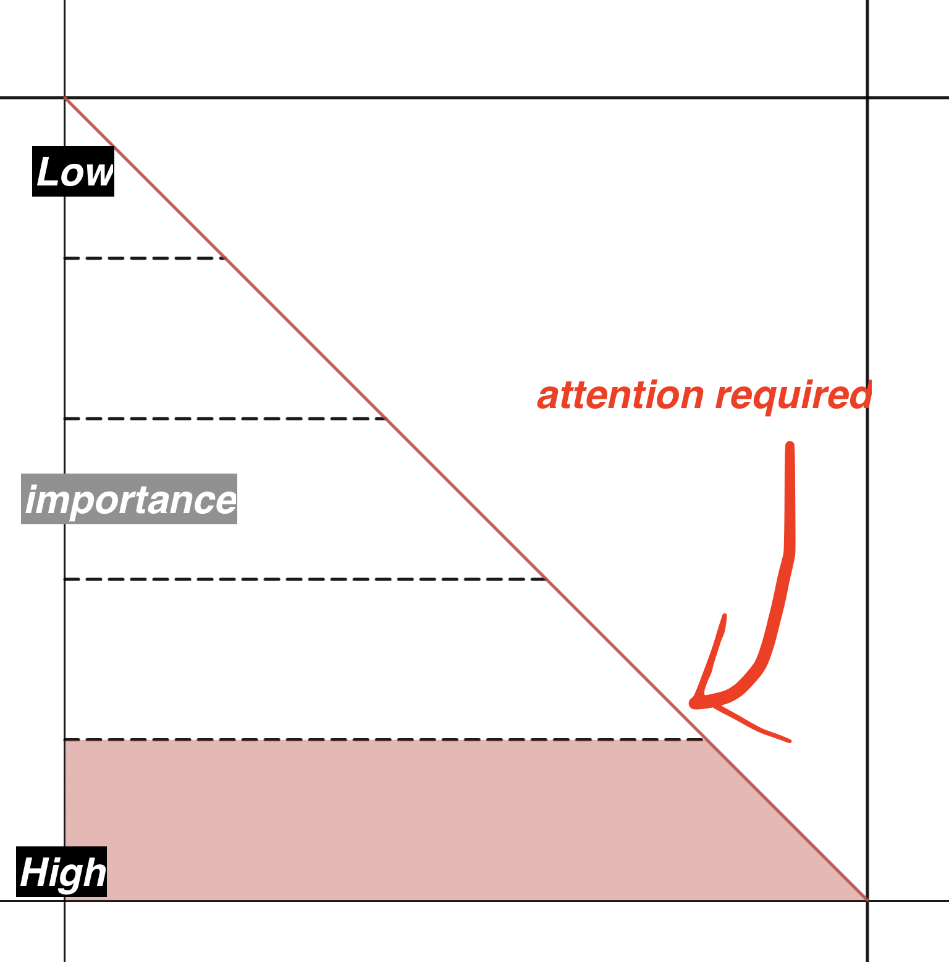

### For a NeuroDivergent

We are constantly assessing this scale. If we’ve learned to be functional in society, we’ve used this scale without even knowing it. Another way to think about it is “what’s the most important thing?” Others can get a sense of when we go “offline” based on how focused on the scale we are. For example, if you only have room on the Table for one item, it should be both the most important item and by the nature of the Table, indicate that you’re overloaded.

In reverse, we can use it to determine priority. The more stressed we are, the more important it is to pay mind to the most important things. We’ll cover this in the Curve.

### The Curve

*A measure of attention to each item on the scale.*

Just as the Scale provides a way to measure the effectiveness of a checklist, the Curve provides a way to measure the effectiveness of the Scale. The purpose of the Curve is to more quickly identify the amount of energy to invest in each item on a scaled Checklist.

The Curve is based on the belief that the most important thing to handle in any situation is the most important thing on The Checklist, and that if we are more stressed or “taxed” - just as we described in the mechanics of the Table - we are less likely to make good decisions Also known as a Trust Curve, the Curve indicates the amount of attention needed on the most important things vs the least. The Curve affects the Scale by adding a “weight” to focus or relax the importance of the most important items on the Checklist.

Thought Experiment:

If you approach someone at a table and they’re fervently trying to keep it organized, that can be disorienting. They may think they’re paying attention to the most important thing, but because of the mechanics of the Table, they are not. If you were to organize the table for them, it would likely take them a bit of time to recognize it has been organized and calm down. They would still be obsessing about the “most important” thing, and it would take some time for them to realize it is handled. Then their minds would move on to the next most important thing, and so on. As they relax, they may get a more grounded sense of the Scale, realizing that they had not been focused on the most important thing. The more time this fervent organization goes on before your intervention, the longer it will take to relax.

The Scale gives us clarity during these times and it can be measured by looking at the clutter on the table, the amount of time it’s been cluttered and the amount of free space.

Said another way, the Curve explains the likelihood of being able to “snap back” from overload, see clearly, and make good decisions. When combined with the Checklist and the Signs, can be a highly effective tool to understand just how critical it is to navigate the Checklist in the proper order.

For instance, if the rating on The Scale is a 10 and Trust is low then it’s even more critical to focus on the most important thing on the scaled Checklist, but if trust is high, then we have a bit more liberty to focus on the second and third Checklist Items with more relative energy.

Let’s look at our example from earlier.

The red line is the curve.

The width of each section is how much energy we should be allocating to each thing.

| **Low Trust - Deep Curve** | **High Trust - Shallow Curve** |  |
| --- | --- | --- |
|  |  | [2] Rocking  [3] Flapping  [7] Listening to music with noise-canceling headphones  [7] Singing  [8] Smoking  [9] Playing guitar  [10] Exercise |

### For The Neurodivergent

Considering this to be like Maslow’s Hierarchy may help communicate this: For example, look here: <https://practicemindfumoney.com/trust>

In some cases, knowing and communicating this curve factor is more important than the Scale because it provides a “leeway” what will statistically increase success. If you pay have the Scaled Checklist and follow it, the mind that is frantically trying to organize the Table will have no choice but to see it as organized. And the sooner, the better. How do we make it sooner? Follow the Checklist.

## The Choice

One bad decision can ruin a lifetime of good ones. Whether we’re talking about money, investing, relationships, or work, bad decisions come with more weight

The worst time someone can make a decision is when their Scale is on the higher end and even worse when there is low trust. For example, if I was having a panic attack and have been having multiple a day and decided to rock, it would have nearly no influence; certainly not as much as playing guitar or exercising.

What if I continued to rock? Would that raise or lower my curve? Would my Curve change faster if I played guitar or exercised instead, according to my scaled Checklist?

A good decision is when the cost of making the decision outweighs the value.

Determining value and cost both require awareness, and that can’t happen when the table is too full. But it’s a LOT easier with a Scaled checklist, and full awareness of the Curve.

### For the Neurodivergent

Don’t choose when your table is too full.

If you find that you’re high on the scale often, turn to a decision-making methodology such as Decisions on Demand to help you choose.

If you make choices from a place where The Scale is too high, you will end up with lower trust.

# Summary - What We’ve Learned

**The Table** is a model to determine mental “fullness” in any moment, and communicating about a table in terms of clutter, fullness, or effort to manage helps.

**The Checklist** is a way to keep the stuff on or off the Table straight, organized, and in a certain context. It is an abbreviated form of much more sophisticated concepts, and can help to reduce Table clutter.

The Signs are a Checklist of what happens during overwhelm as well as what helps overwhelm. They should be references if you’re looking to infer the state of the Table without words.

The Scale is a rating system for the Checklist, allowing us to know the value of each item in comparison to each other item.

The Curve describes how much attention should be paid to each item on the scaled Checklist, and is based on prior conditioning, and momentary overwhelm.

The Choice is the current moment - what will you do right now? Use the tools we’ve given you and see the change you can make.

~~Scraps~~

~~But first, there’s a big lie that we’ve all (ND or not) been sold about communication. None of us actually WANT conflict. The only reason we have misunderstandings, stress, anxiety, or overload is because of stress. Stress can be mental, emotional, physical, environmental, or virtual (made up thoughts) and can be the result of external influence, internal influence, trauma, and more.~~

As humans, communication comes naturally without effort - that’s why we have language to start with. It’s why we have cells that communicate without language. Stress inhibits effortless communication.

Sometimes, confusion increases when we use words, especially if we’re using the same words and they have fundamentally different meanings to each person. For example, draw a big circle and label it “love.” Then, without censoring, write several (at least 7) words in the circle that represent love. Then ask a friend, family member, or partner to do the same. The words in the circle represent your mental map of love, and so do theirs. They may have similar traits, but they are rarely the same.

This is especially true when our inability to process information becomes overwhelming and we can no longer choose words that connect to our intended meaning. This is a sure sign of stress.

We’re happy to discuss how to directly implement these in your life.

Just click here for an introductory session: <https://calendly.com/practicemindfulmoney/15min>